FYC EXTRAS E-BLAST GUIDE & TEMPLATE

E-Blast approval is required 24 hours in advance.
Please email E-Blast drafts for approval to:

Jon Brockett jbrockett@sagawards.org
Jen Coyne-Hoerle jench@sagawards.org
Sarah Barry sbarry@sagawards.org

You may send up to 2 FYC Extras E-Blasts (per title) to Nom Comm members with links to additional FYC bonus features. All FYC extras must be performance focused.

Formatting
- FYC Extras E-Blasts must be submitted as Word .doc files. PDFs will not be accepted.
- Up to 2 images or graphics may be included on each blast. We suggest title treatment and / or a one-sheet.
  - Title treatments must be .png and between 700 and 1000 px wide.
  - One-sheets and photos must be .png and between 1081px x 1600pm.

Language
- All E-Blasts must include “Paid For” text below:
  - NOT PAID FOR BY SAG-AFTRA – or – PAID FOR BY [STUDIO/COMPANY]
- Any reference to the Nominating Committee must be referred to as the “SAG Awards Nominating Committee” or “SAG Awards Nom Comm.” Please do not use just “SAG” or “SAG Nom Comm.”

Allowed Content to Link - Limit of up to 3 links per E-Blast

- Pre-Recorded Panels/Events
- Trailers
- Featurettes
- Behind-the-Scenes
- Interviews
- Digital FYC Booklets
- Screening Website

Details to Include
- Please only provide hyperlinks. Videos cannot be embedded.
- Password info if applicable.
- Brief explanation of extra(s).
- Up to 2 reviewers quotes may be included.
- Additional Studio / Network Piracy and / or Viewing Guidelines if applicable.

Fees
- $1,000 fee per national FYC Extras E-Blast.
- These fees will be invoiced in early April once Awards season concludes.

TEMPLATE TO FOLLOW

You are invited to view special bonus content of
TITLE OR TITLE ART
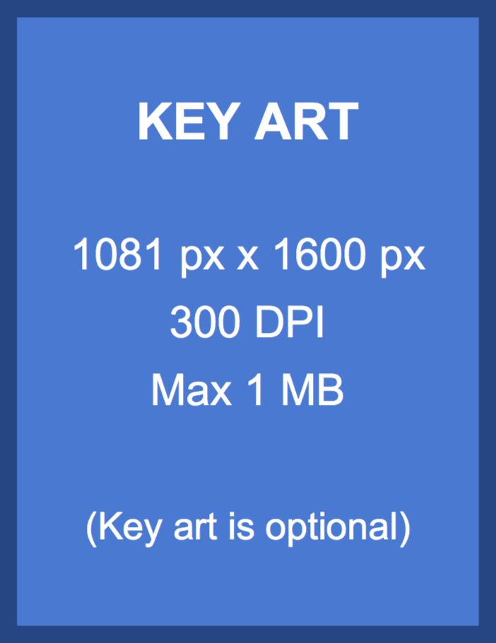

Up to 3 linked Extras with password info if applicable
Brief Explanation of Extra Item(s)

ABOUT TITLE
Description of title being screened.

NOT PAID FOR BY SAG-AFTRA
– OR –
PAID FOR BY STUDIO / PRODUCTION COMPANY / NETWORK

Additional Studio / Network Piracy and / or Viewing Guidelines (if applicable)

Online FYC viewing content is the copyrighted property of the networks, studios, and production entities who supply them and is made available for your personal consideration as a member of the 27th Annual Screen Actors Guild Awards® Nominating Committee. Sharing login information or your Awards PIN with anyone is STRICTLY PROHIBITED.

Screen Actors Guild Awards, LLC and SAG-AFTRA ("Parties") make no representation or warranty about any websites you may access to view FYC content or events. The parties have no control over the operation of the respective websites, nor over the use of disclosures of personal information you choose to share with them. Registration with and/or usage of such websites are subject to the respective sites. Information you choose to share with the entity will be used for purposes of providing the FYC content or event information.

